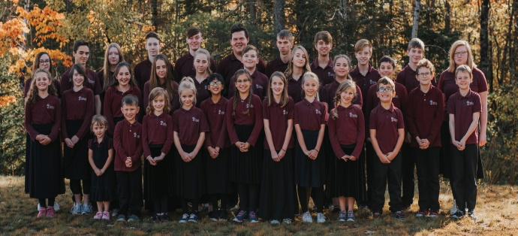
School News ~ September 2019 Edition

Regional Student Convention
Regional Student Convention was held April 8 & 9, 2019 at the Geary Baptist Church. Students from A.C.E. schools and homeschools in New Brunswick attended this event.
HCS began the 2019/20 school year with 32 students.

The guest speaker, Alfred MacLaren, Manager of A.C.E. Canada, spoke on “Lighting Your World.”
A visit by Canuck, the mascot for A.C.E. Canada, was enjoyed by students and adults alike.
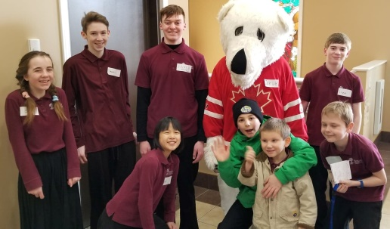
International Student Convention (I.S.C.)
The competition was intense at the 2019 I.S.C. in Warrensburg, Missouri, in May, but HCS finished strong. With the support of the 10
HCS Flag Corps placed third at I.S.C.

staff/chaperones/guests in attendance, 8 students brought 8 awards back to their school.
Awards were won by both individuals and teams of students from HCS, ages 13 to 17. These included Flag Corps, Scrapbooking, Poetry Writing, Vocal Quartet, Expressive Reading, Photography, and Soccer Kick. Five medals were awarded within the top 15 placements. HCS students competed with other A.C.E. students who were regional winners from 24 countries around the world.
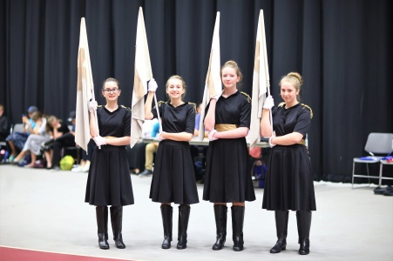
One HCS student won free registration to Service Adventure in Thailand or Mexico, Summer 2020. Service Adventure is a two week summer mission trip that challenges you to experience service and ministry in a foreign A.C.E. school.
A Visit to the Prayer Garden
Earlier this year, students and staff visited the Prayer Garden in Tracy. As they stopped at each Station of the Cross, they were reminded of God’s great love for us.
Songs, Scriptures, and prayers from staff and students alike made the visit even more meaningful.
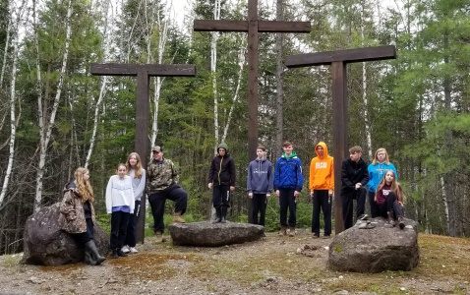

Flamingo Fundraiser
A fun new fundraiser enables someone to anonymously cover a recipient’s lawn with 25 pink flamingos and celebratory signage (Happy Birthday or Anniversary, Congratulations, or You’re the Best).
For additional information, please contact Patti Nason (506) 440-5397.
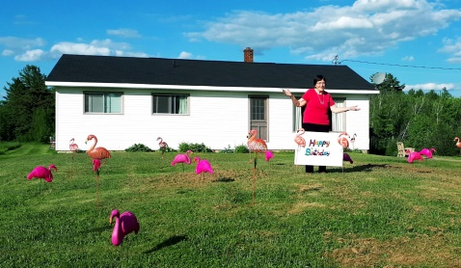
Surprise! Happy “milestone” birthday,
Mrs. Burtt!

Sandy Cove Bible Camp Year-end Trip
HCS students enjoyed a year-end overnight trip to Sandy Cove Bible Camp at Davidson Lake. 25 students and 8 staff/chaperones attended the camp. The following short interview provides feedback from a few very satisfied participants:
Mrs. Burtt (a.k.a. Grammie): “What is the first thing you think about when I mention your trip to Sandy Cove?”
Charlie (age 12): “Kayaking.”
Rosie (age 7): “Eating.”
Grammie: “What do you think of when I mention camp rules?”
Charlie: “Lights out at 10:00 p.m.”
Rosie: “That didn’t help me! I didn’t get much sleep because the older girls in the other end of my cabin were laughing their heads off all night long!” (Note added later: According to Miss Burtt, the older girls settled down before 11:00 p.m.)
Charlie: “The boys slept well, but some of us were up early. The camp leader, Gary Long, said he was surprised when he got up at 6:00 a.m. and saw us outside playing on the swings.”
Grammie: “Is there anything else you would like to say about Sandy Cove?”
Charlie: “It was so much fun! The mini golf was a real hit with Luke, Liam, and me! Everyone loved the Family Feud Game.”
Rosie: “The most fun for me was playing on the swings with Hadassah!”
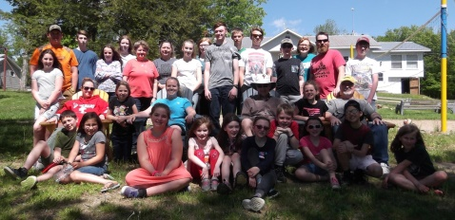
HCS students, staff, and chaperones assembled for a brief photo shoot before getting back to all the fun!

Alumni Update
We know God is at work in the lives of many of our alumni. We wanted to take a moment to mention one lady who has been a special blessing to HCS in recent years. Candice Arndt (now Strang) graduated in 2013. After attending Majestany Institute she began her career as a hair stylist. Currently she has her own mobile business with many happy clients. She is also following her passions and runs Sondance Studios teaching dance to little girls and young ladies. She is active in her church with both music and children’s programs. She and her husband are parents to Bella and expecting a baby boy in November. Candice has faithfully been teaching a weekly physical education class to HCS students for the last couple of years. (She continued this through her pregnancy and immediately after!) She directed last year’s Christmas program, helps judge at student conventions, and is working with students to prepare performances for this year’s Christmas program. We are thankful and blessed to see Candice and other alumni serving the Lord and following His plan for their lives. Our supporters can be encouraged to know they have made a difference by investing in the lives of our students.
The I.S.C. Opening Rally featured former HCS student, Victoria Johnson, being interviewed by Ray Marin, Director of Admissions for Accelerated College of the Bible International. Miss Johnson is now on staff at HCS. 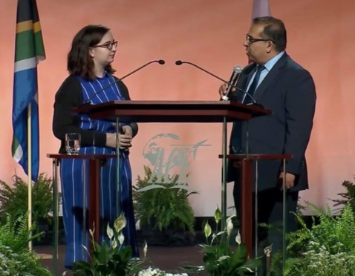

Note: Stay tuned! Another update on HCS “happenings” is expected early in the new year.

